2. A 26 KVA, 260/130 V single phase transformer has an efficiency of 94% and a full load unity power factor. It is connected as an autotransformer with an input voltage of 260 V to feed a load of 390 V. What will the autotransformer's full load efficiency be at unity power factor? Draw the autotransformer circuit.

- Votage rating of auto transformer = 260 V / 390 V
K = 390/260 = 1,5
KVA rating of Auto transformer = ( K / K-1 ) KVA rating of two winding transformer = 78 KVA
Total losses in 2 winding transformers = total losses in auto transformer
$$η_{2winding}= \frac{26⋅{10}^{3}⋅1}{26⋅{10}^{3}⋅1+total losses}=0.94$$

Total losses = 3,191 KW

$$η_{AutoT∕F}= \frac{78⋅{10}^{3}⋅1}{78⋅{10}^{3}⋅1+3,191⋅{10}^{3}}=0,9607=96,07 \%$$
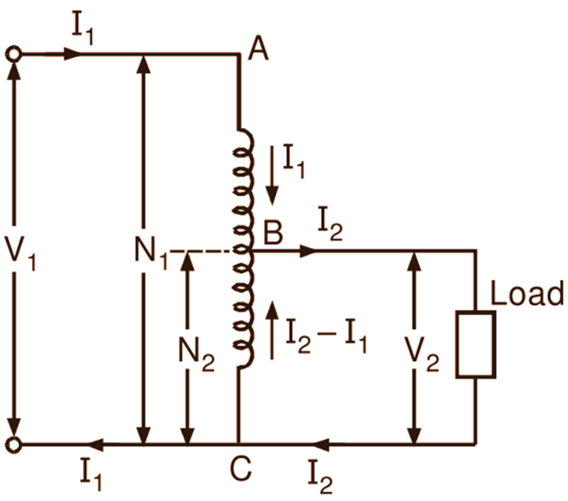

4. A two winding single phase transformer rated 60 kVA, 240/1200 V, 60 Hz, has an efficiency of 96% when operated at rated load, 0.8 power factor lagging. This transformer is to be utilized as a 1440/1200 step-down autotransformer in a power distribution system. (a) Assuming the transformer is ideal, that is neglect the efficiency data above for this part, determine the maximum permissible kVA rating of the autotransformer if the winding currents and voltages are not to exceed their two-winding transformer ratings given. (b) Now consider the efficiency data above, that is the equipment is not ideal anymore, determine the efficiency of the autotransformer with the kVA that you found in part (a) and 0.8 power factor leading.
(a) Determining the maximum permissible kVA rating of the autotransformer without considering efficiency:
The autotransformer utilizes the original transformer with the following specifications: 60 kVA, 240/1200 V.
For an autotransformer, the apparent power (kVA) is shared between the primary and secondary sides. Since the autotransformer is step-down (1440/1200), the primary side is 1440 V and the secondary side is 1200 V.
The ratio of power transmission between primary and secondary sides is determined by the voltage ratio:
Voltage Ratio = 1440/1200=1.2 V
The kVA ratio will be the square of the voltage ratio because power is proportional to the square of the voltage:
kVA Ratio = (Voltage Ratio)^2 = 1.22^2 = 1.44kVA
Now, to find the maximum permissible kVA rating on the secondary side of the autotransformer:
Maximum kVA=Rated kVA×kVA Ratio=60 kVA×1.44=86.4 kVAMaximum kVA=Rated kVA×kVA Ratio=60kVA×1.44=86.4kVA
Therefore, the maximum permissible kVA rating of the autotransformer, neglecting efficiency, would be 86.4 kVA.
(b) Determining the efficiency of the autotransformer with the kVA found in part (a) and 0.8 power factor leading:
$$η_{2winding}= \frac{60⋅{10}^{3}⋅1}{60⋅{10}^{3}⋅1+total losses}=0.96$$
Total losses = 2,5 KW

$$η_{AutoT∕F}= \frac{86,4⋅{10}^{3}⋅1}{86,4⋅{10}^{3}⋅1+2,5⋅{10}^{3}}=0,9719=97,19 \%$$

